ConnectiCOSH
2022 Ray Elling In person/Hybrid
Health and Safety Convention

Workplace Health and Safety: Looking Back and Moving Forward
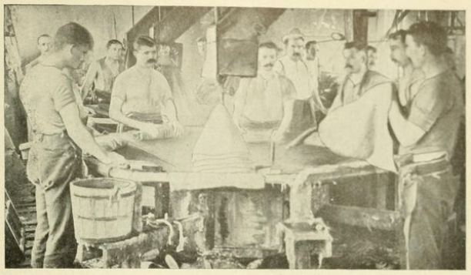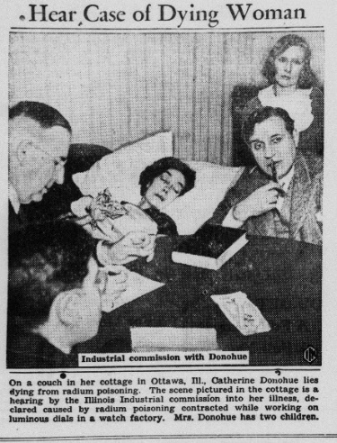
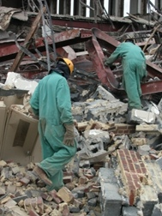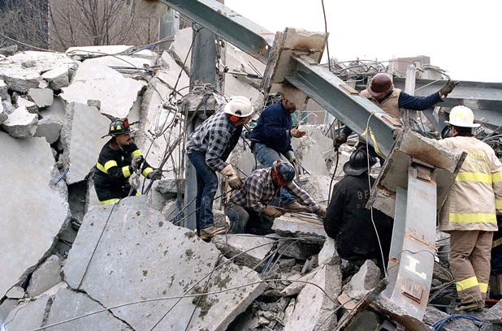

Friday, November 18, 2022
8:00am - 4:00pm
IAM Local 1146 Union Hall
357 Main Street, East Hartford, CT

September 21, 2022

Brothers and Sisters,

We hope that you are all healthy and ready to gather together at the Ray Elling Health and Safety Convention to learn about various workplace health and safety topics and to share your experiences. While the convention has been held virtually these past two years, this year, on November 18, from 8:00 – 4, we will be offering both an in-person option at the IAM Local 1746, 357 Main Street, East Hartford, CT as well as an online option via Zoom to allow for the comfort of all who would like to participate.

The convention will include an interactive swap meet and informative workshops but in place of a single keynote speaker this year we will have a panel of advocates on various Connecticut workplace tragedies that have occurred through the years as well as leaders in present day organizing movements. This panel will be Looking Back and Moving Forward as they look back historically, view more recent events, and set a trajectory for improvements in the upcoming years for both worker safety and union activity.

In keeping with CDC guidelines, face coverings or N95 respirators are recommended, but not required. We will adjust recommendations and requirements for the in-person event if statistics regarding SARS-Cov-2 change substantially. There will be a fee for attendees of the in-person event; members receive a discounted rate. There will not be a fee for individuals who are attending remotely.

ConnectiCOSH continues to:

- educate injured workers to protect their legal rights
- be active members of the Coalition for a Safe and Healthy Connecticut fighting for chemical substitution and reducing exposure to toxic chemicals
- partner with UCONN and Yale Occupational Environmental Health Clinics
- present awareness level trainings to vulnerable workers
- train Hazardous Waste Site Workers and Emergency Responders as part of a joint effort with The New England Consortium
- organize and participate in Worker Memorial Day events across the state

Why join ConnectiCOSH?

- technical and legal support on workplace hazards
- assistance in filing OSHA complaints and follow-up
- help in researching hazards in your workplace
- speakers and materials for your membership or steward meetings
- workshops on hazards, organizing strategies and leadership development
- coordinate campaigns to pressure for tougher state and federal laws regulations

Your support can make the difference

It would not be possible for ConnectiCOSH to do this work without your financial support and organizational solidarity. Your dues payment as well as your participation in future events is our only guarantee that the movement for safe and healthy workplaces will continue to grow. Standard dues rates are listed below, but, in these tough times, anything that you can afford will be appreciated.

Thank you in advance for your continued support and best wishes for your continued health and safety.

Steve Schrag Ashley Collins
ConnectiCOSH Chair ConnectiCOSH Health Tech Committee Chair

United together we can make sure that more workers go home to their family healthy and safe.

Dues Structure
Individuals |  | Union Locals
$25 | Individual Membership | $50 | Less than 100 members
$50 | Contributing Membership | $100 | 100 – 500 Members
$100 | Sustaining Membership | $200 | 501 – 2000 Members
 |  | $300 | 2001 – 5000 Members
 |  | $500 | Over 5000 Members

Please make check out to ConnectiCOSH and mail to: ConnectiCOSH
683 North Mountain Road
Newington CT 06111

Convention Registration form

Name _____________________________________________________

Address ___________________________________________________

___________________________________________________

Phone ____________________________________________________

E-mail ____________________________________________________

Union or Organization________________________________________

In-Person _____________________ Online ______________________

___COSH Member $45
___Students/Unemployed/low income $10
___Non-members $65

Coffee, lunch and refreshments are included.

Individual membership is only $25, which gives you the lower conference fee.

Please inform us if you would like to attend remotely. After we receive your registration, we will email you the Zoom invitation.

